Greetings Timberline Member,
The board is contacting you to inform you of a special meeting as required in our Bylaws for approval of a capital project that will exceed $10,000. Please note we are not requesting any additional contributions from members - we simply need approval to spend our existing funds on the following repairs to the swimming pools.
The meeting will be on January 31st, at 5:00 pm at the club house.
The project consists of three items related to the pools.
- Replastering of both pools.
- Replacing the caulking on both pools that is between the pool deck and the coping stones around the pool. (This issue has been written up on the last two Health Department Inspections to be repaired.)
- Remove and reattach with mortar the coping stones that have lost their bond to the pool substrate. (Safety Issue.)
At the September meeting, $50,000 was approved via a vote of the members present. At that time a formal quote had not yet been received. The formal quote is for a total of $57,240. This is for the replastering only. The last time the pools were replastered 12 years ago it was done for $50,000.
Below is the recap for review of all three items
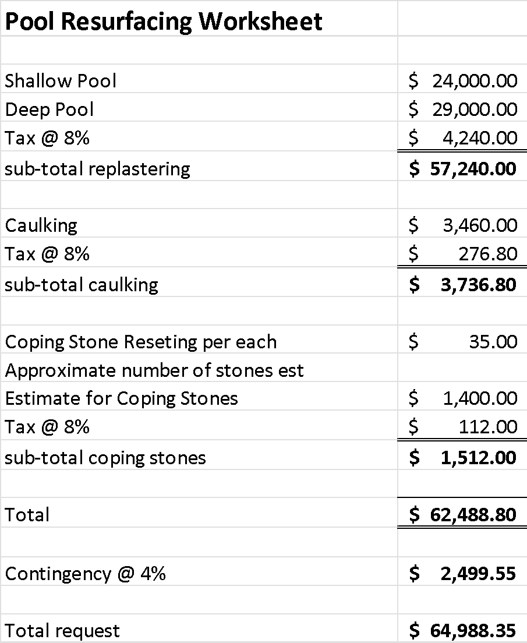
We are requesting approval of this expenditure, $64,988.35. Votes may be cast in person or by written proxy at any membership meeting. A “written proxy” shall be valid if provided on the approved form and delivered to the Secretary by personal delivery, regular mail, or electronic transmittal (email), prior to commencement of a meeting of the Association. The approved form for a valid written proxy is available on the Association website, or may be obtained from the Secretary. A “written proxy” grants power of attorney for casting the absentee’s vote to the person designated on the form, but does not include direction of how such vote shall be cast. Email address for sending any proxy’s to the Secretary is timberlinecommunity@gmail.com.

